Test # 389
Instrument Name Consistometer #113 (1)
Instrument Type Consistometer
Test Start 14/07/01 10:16
Test Stop 3:41:50
Well ID #
Customer LUKOIL
Cement Class G
Additives 0.33%THR-100+30%SilicaFlour+Dfmr
Cement Mfr DYKERHOFF
BHCT 158
BHST 158
Density 1960
Fluid Loss
Job Type PLUG

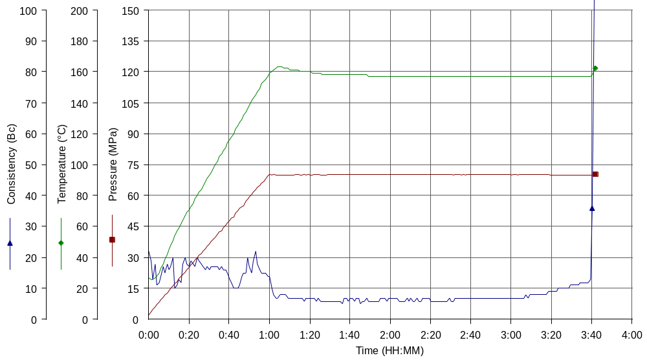
Comments MPa: 70(60min); T: 140C (50min), 158C(10min); tap water

